ALOK KUMAR GAUTAM
ASSIGNMENT-1
Practice 1
Part 1
Test your knowledge:
1. The following SELECT statement executes successfully:
SELECT last_name, job_id, salary AS Sal
FROM employees;
True/False
Ans-True
2. The following SELECT statement executes successfully:
SELECT *
FROM job_grades;
True/False
Ans-True
3. There are four coding errors in the following statement. Can you identify them?
SELECT employee_id, last_name
sal x 12 ANNUAL SALARY
FROM employees;
Ans- SELECT employee_id, last_name, salary * 12 "ANNUAL SALARY"
FROM employees;
Part 2
4. Your first task is to determine the structure of the DEPARTMENTS table and its contents.
Ans-----> DESCRIBE DEPARTMENTS;
---> select department_id, department_name, manager_id, location_id
from departments;
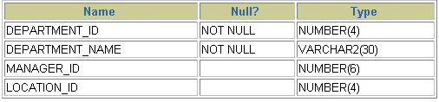
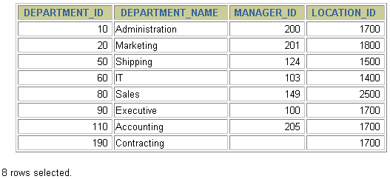
5. You need to determine the structure of the EMPLOYEES table.
Ans -DESCRIBE EMPLOYEES;
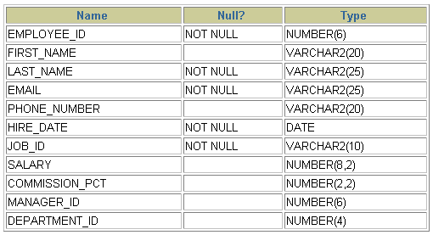
The HR department wants a query to display the last name, job code, hire date, and employee number for each employee, with employee number appearing first. Provide an alias STARTDATE for the HIRE_DATE column. Save your SQL statement to a file named lab_01_07.sql so that you can disperse this file to the HR department.
Ans- SELECT employee_id, last_name, job_id, hire_date StartDate FROM employees;
- Test your query in the lab_01_07.sql file to ensure that it runs correctly.
Ans-- SELECT employee_id, last_name, job_id, hire_date StartDate FROM employees;
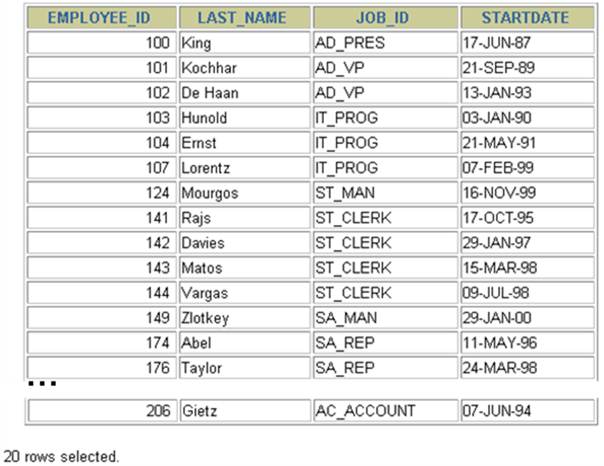
- The HR department needs a query to display all unique job codes from the EMPLOYEES table.
Ans- select distinct job_id
from employees;

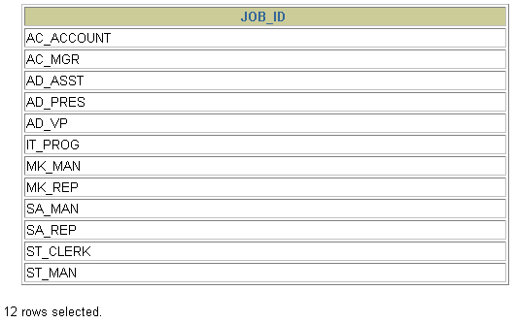
- The HR department wants more descriptive column headings for its report on employees. Copy the statement from lab_01_07.sql to the iSQL*Plus text box. Name the column headings Emp #, Employee, Job, and Hire Date, respectively. Then run your query again.
Ans- select employee_id "Emp#", last_name "Employee", job_id "Job", hire_date "Hire Date"
from employees;
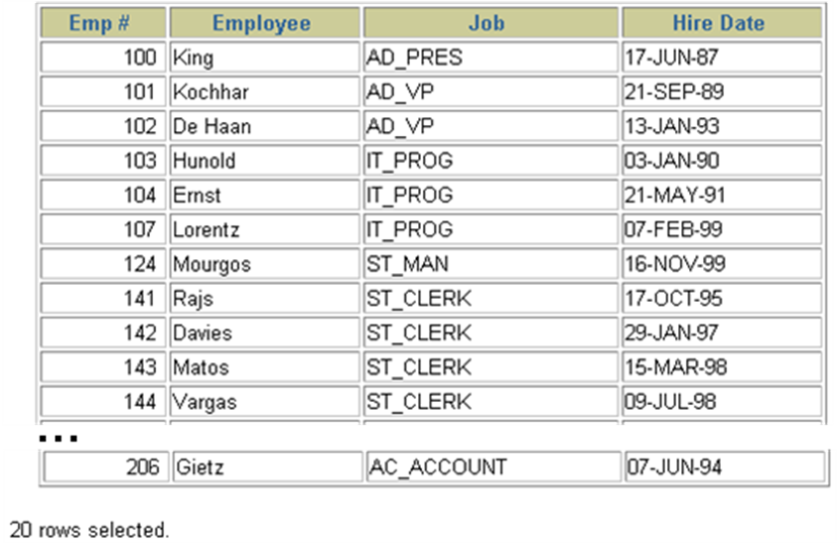
- The HR department has requested a report of all employees and their job IDs. Display the last name concatenated with the job ID (separated by a comma and space) and name the column Employee and Title.
Ans- select last_name||', '||job_id "Employee and Title" from employees;
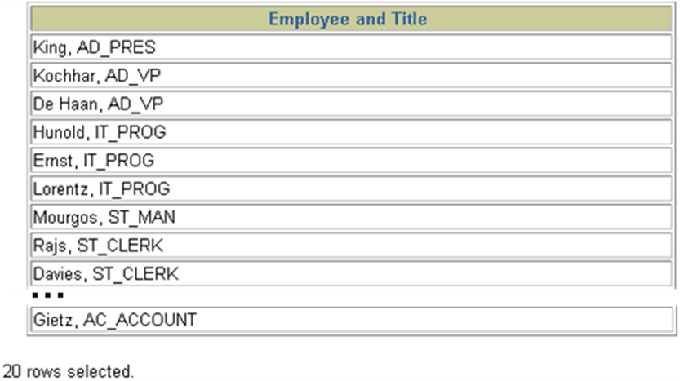
- To familiarize yourself with the data in the EMPLOYEES table, create a query to display all the data from that table. Separate each column output by a comma. Name the column title THE_OUTPUT.
Ans-- select employee_id||','||first_name||','|| last_name||','||email||','||phone_number||','||hire_date||','||job_id||','||salary||','||commission_pct the_output from employees;
